Non-Uniform Non-Convex Polyhedra

Definition
# Source: AI Source: Provided by: [Data Path: Persons Table -> ID Column: 1, Name_En Column: Motasem Essam] -> From: [ChatGPT] on [7/25/2026]
A Non-Uniform Non-Convex Polyhedron is a polyhedron that has a non-convex geometric structure and does not have a symmetry group that maps every vertex to every other vertex.
It combines two distinct properties:
- Non-convexity: The solid has at least one inward indentation or re-entrant region. A line segment joining two points of the solid may pass partly outside it.
- Non-uniformity: Its vertices are not all geometrically equivalent under the symmetries of the solid.
Its faces may be regular polygons, irregular polygons, or a mixture of both. Its edges and vertex arrangements may also differ.
Important distinction: A non-convex polyhedron is not automatically non-uniform. Non-convex uniform polyhedra exist, including the Kepler–Poinsot polyhedra. This topic concerns non-convex polyhedra that are also non-uniform.

Geometric Structure
# Source: AI Source: Provided by: [Data Path: Persons Table -> ID Column: 1, Name_En Column: Motasem Essam] -> From: [ChatGPT] on [7/25/2026]
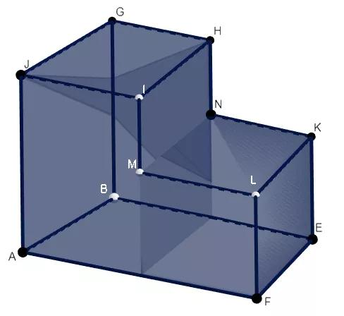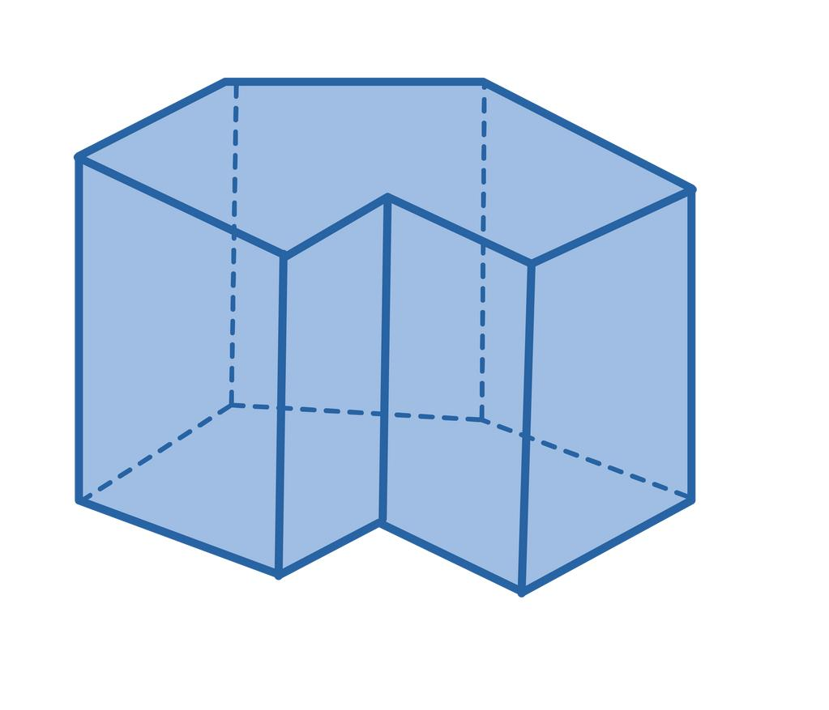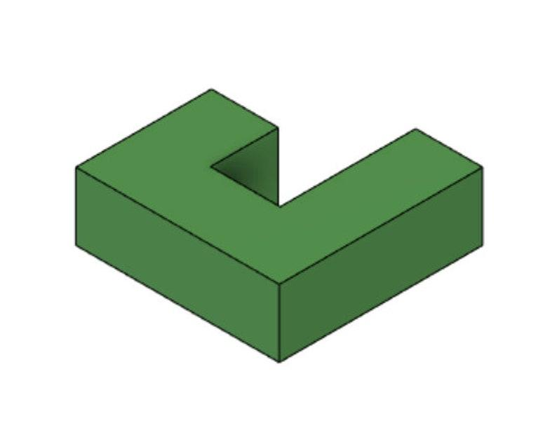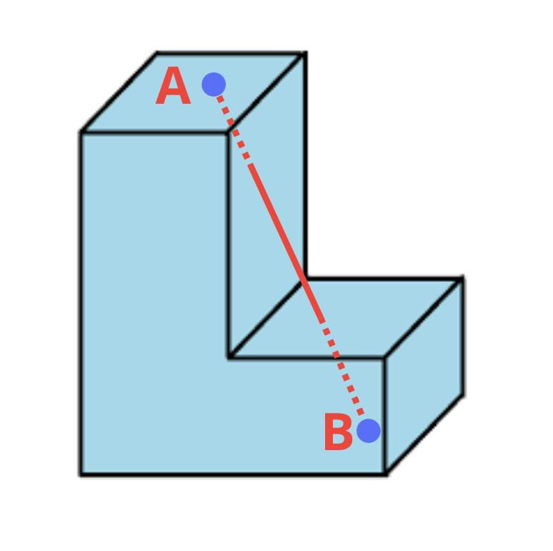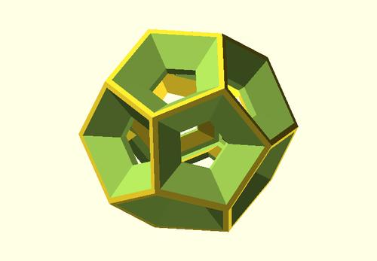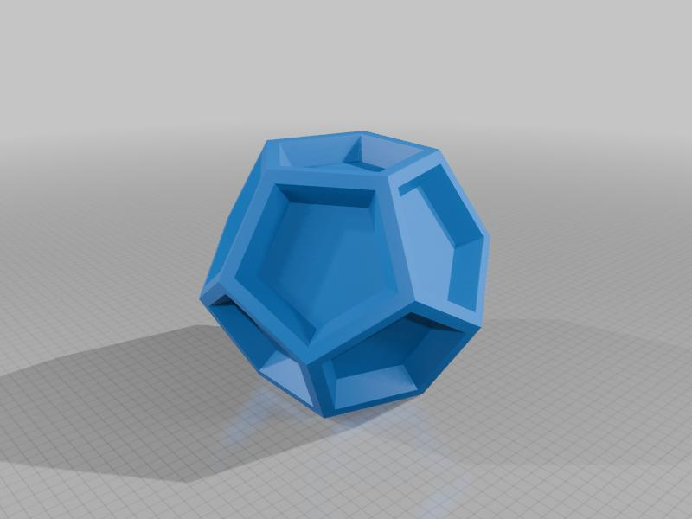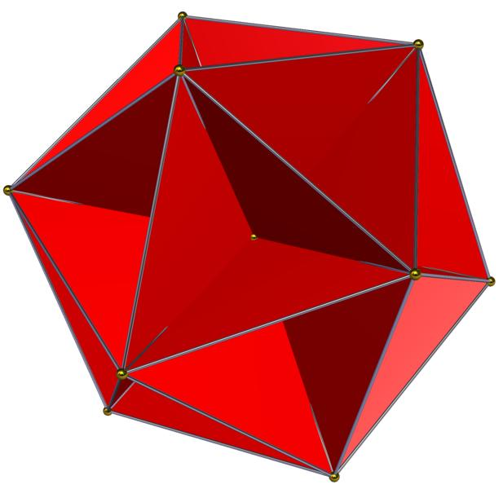

Main Characteristics
# Source: AI Source: Provided by: [Data Path: Persons Table -> ID Column: 1, Name_En Column: Motasem Essam] -> From: [ChatGPT] on [7/25/2026]
- Non-Convex Shape: The solid contains inward regions or re-entrant geometry.
- Non-Uniform Vertices: Its vertices are not all equivalent under the symmetry group.
- Variable Face Shapes: Faces may be regular, irregular, or mixed.
- Variable Edge Lengths: Edges may have different lengths.
- Different Vertex Configurations: Different vertices may have different numbers or arrangements of adjoining faces.
- Complex Geometry: The solid may contain notches, cavities, indentations, or intersecting components.
- Variable Symmetry: It may have partial symmetry or no nontrivial symmetry.

Types of Non-Uniform Non-Convex Polyhedra
# Source: AI Source: Provided by: [Data Path: Persons Table -> ID Column: 1, Name_En Column: Motasem Essam] -> From: [ChatGPT] on [7/25/2026]
The following is a practical structural classification. These types are descriptive categories rather than a universally standardized mathematical taxonomy.

Concave Indented Polyhedra
# Source: AI Source: Provided by: [Data Path: Persons Table -> ID Column: 1, Name_En Column: Motasem Essam] -> From: [ChatGPT] on [7/25/2026]
A Concave Indented Polyhedron is a polyhedron with one or more inward depressions or indentations in its outer structure.
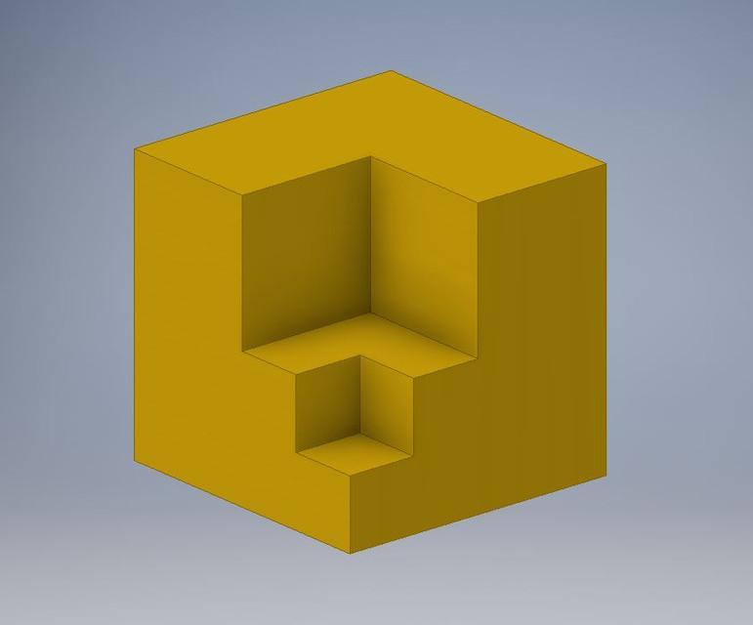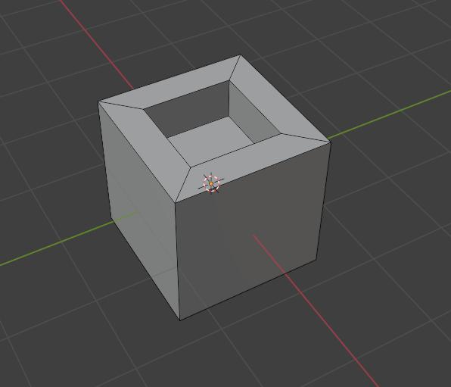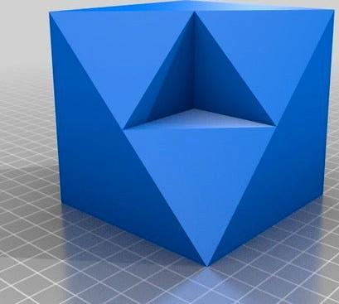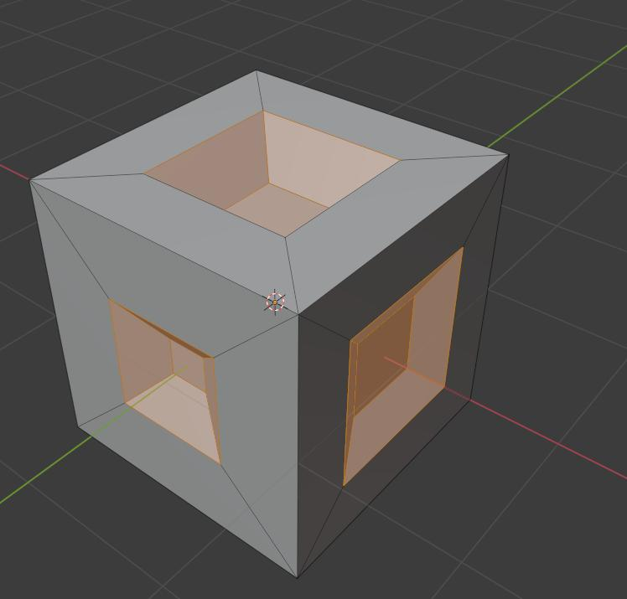
Characteristics:
- Contains inward-facing regions.
- Has an overall non-convex shape.
- May have polygonal faces of different sizes.
- Can be formed by removing a portion of a convex polyhedron.
Examples:
- Indented cube.
- Dimpled polyhedron.
- Concave tetrahedron-like polyhedron.

Notched Polyhedra
# Source: AI Source: Provided by: [Data Path: Persons Table -> ID Column: 1, Name_En Column: Motasem Essam] -> From: [ChatGPT] on [7/25/2026]
A Notched Polyhedron is a polyhedron with one or more portions removed from its boundary, producing a notch or inward opening.
Characteristics:
- Contains one or more notches.
- Has re-entrant edges or vertices.
- May have triangular, quadrilateral, or other polygonal faces.
- Can be produced by cutting away part of an existing polyhedron.
Examples:
- Notched cube.
- Edge-notched tetrahedron.
- Notched prism.

Concave Composite Polyhedra
# Source: AI Source: Provided by: [Data Path: Persons Table -> ID Column: 1, Name_En Column: Motasem Essam] -> From: [ChatGPT] on [7/25/2026]
A Concave Composite Polyhedron is formed by joining two or more polyhedral components in an arrangement that produces a non-convex overall structure.
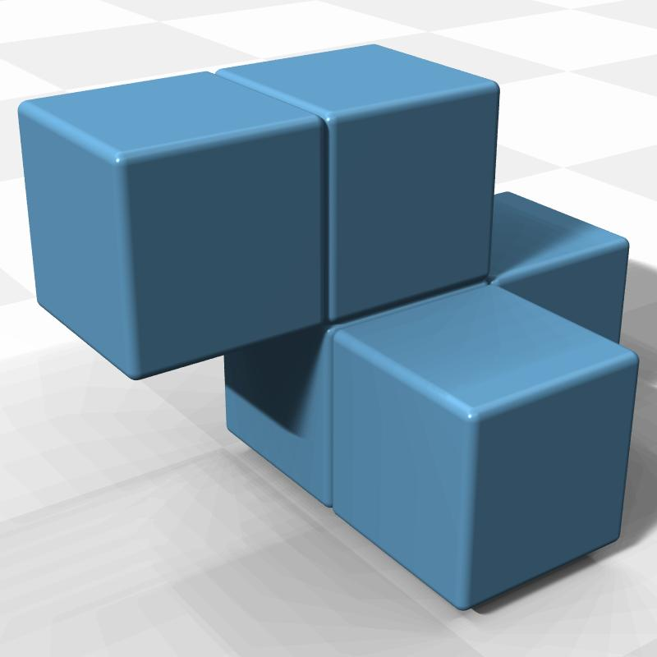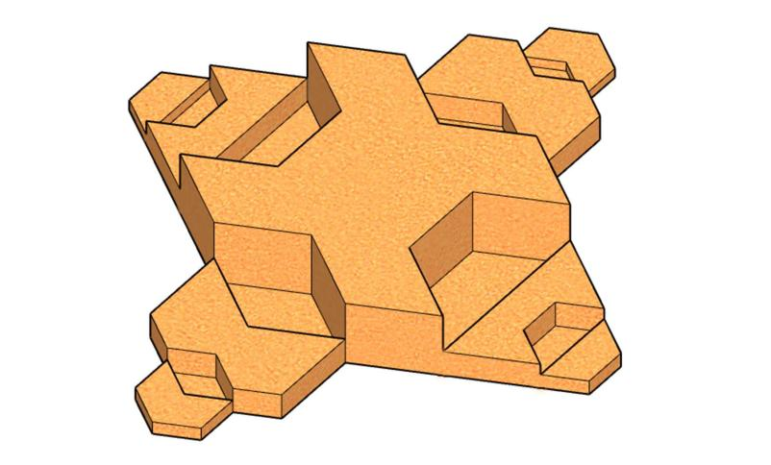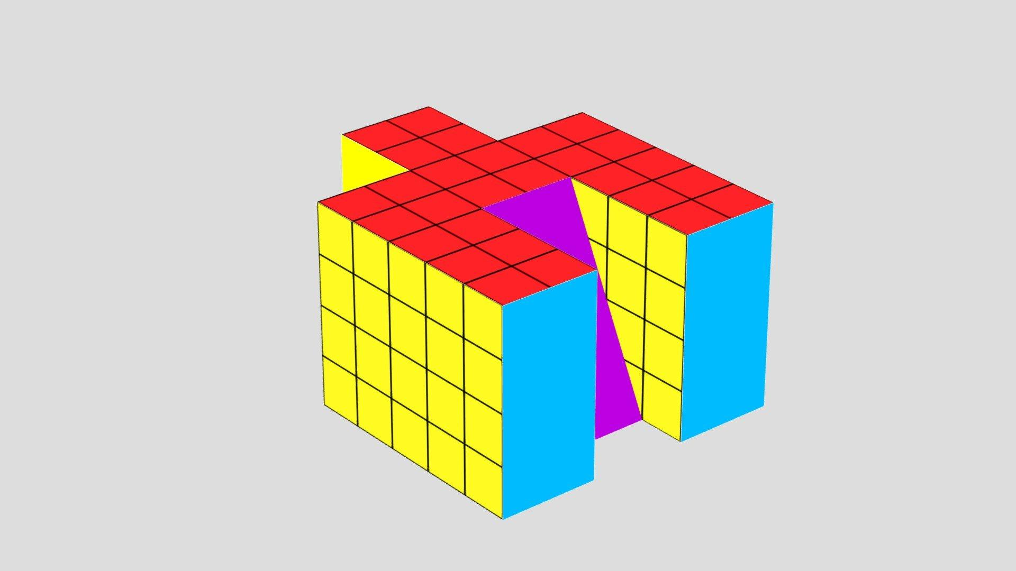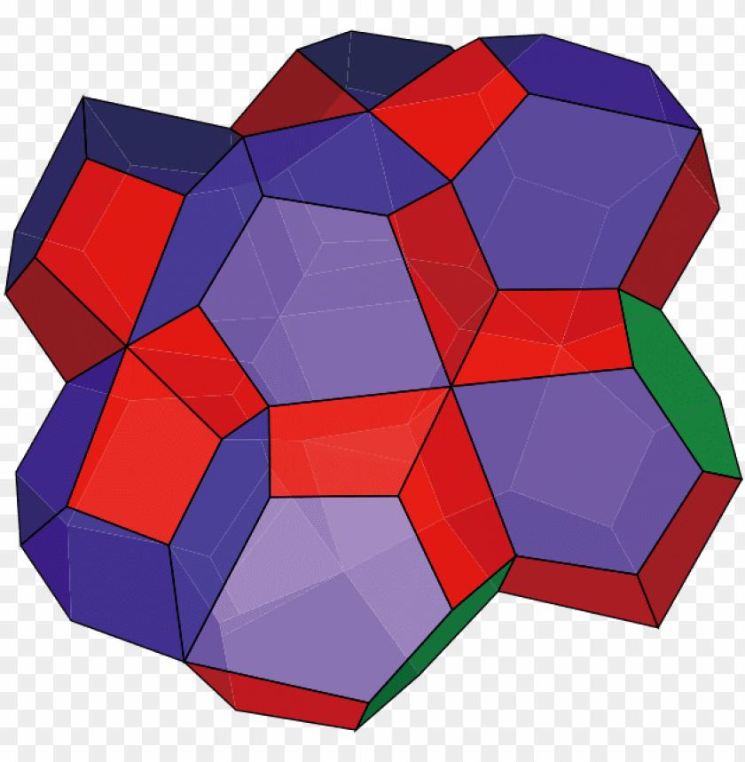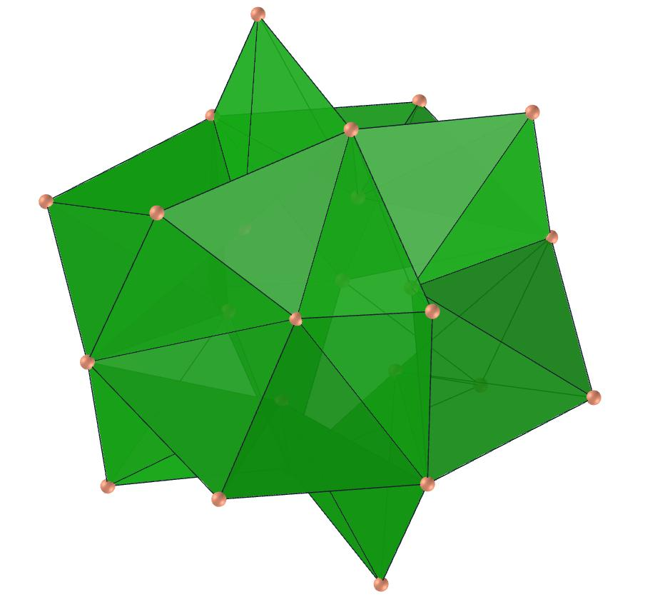
Characteristics:
- Contains multiple geometric components.
- Components may have different dimensions.
- The combined boundary may contain inward regions.
- Individual components may be convex even though the combined solid is non-convex.
Examples:
- Joined cubes with an inward corner.
- Combined prisms forming an L-shaped solid.
- Interlocking polyhedral components.

Re-Entrant Polyhedra
# Source: AI Source: Provided by: [Data Path: Persons Table -> ID Column: 1, Name_En Column: Motasem Essam] -> From: [ChatGPT] on [7/25/2026]
A Re-Entrant Polyhedron is a non-convex polyhedron with inward-facing corners or regions where the surface turns back toward the interior.
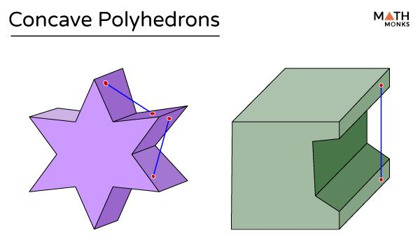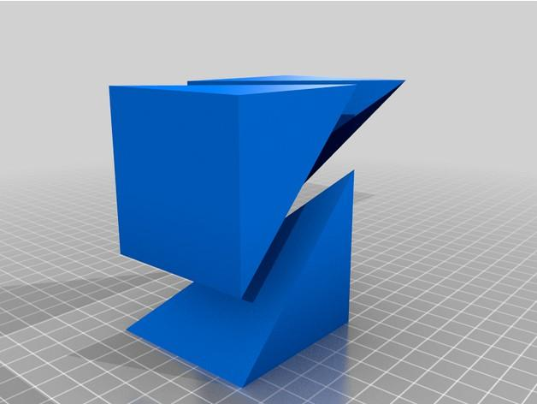
Characteristics:
- Contains re-entrant vertices or edges.
- Has inward-facing surface regions.
- May have several concave portions.
- Can contain multiple connected inward indentations.
Examples:
- L-shaped polyhedron.
- Cross-shaped polyhedron.
- T-shaped polyhedron.
- Star-shaped concave block.

Polyhedra with Cavities or Through-Holes
# Source: AI Source: Provided by: [Data Path: Persons Table -> ID Column: 1, Name_En Column: Motasem Essam] -> From: [ChatGPT] on [7/25/2026]
These are polyhedral structures containing one or more openings or tunnels through their geometry.
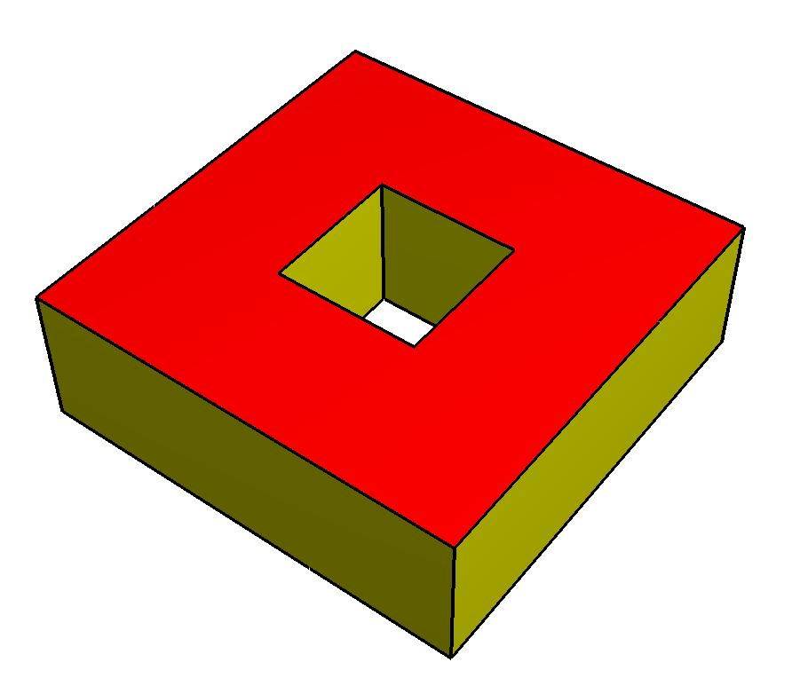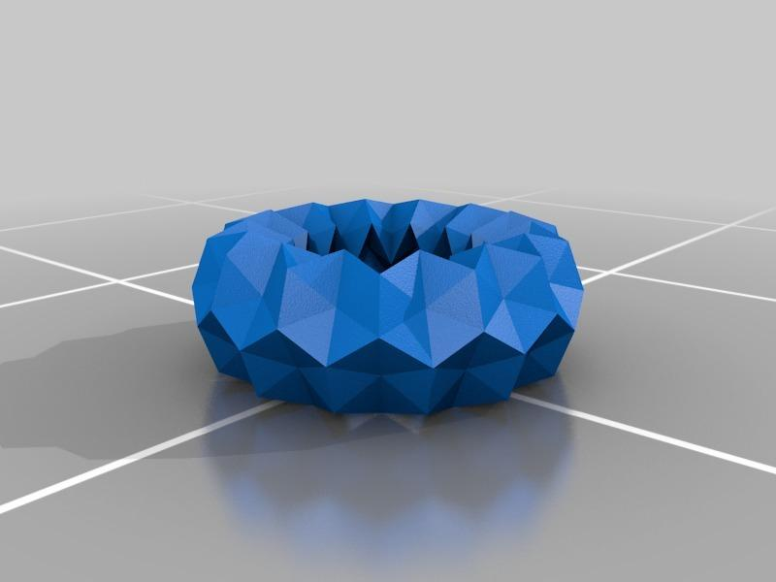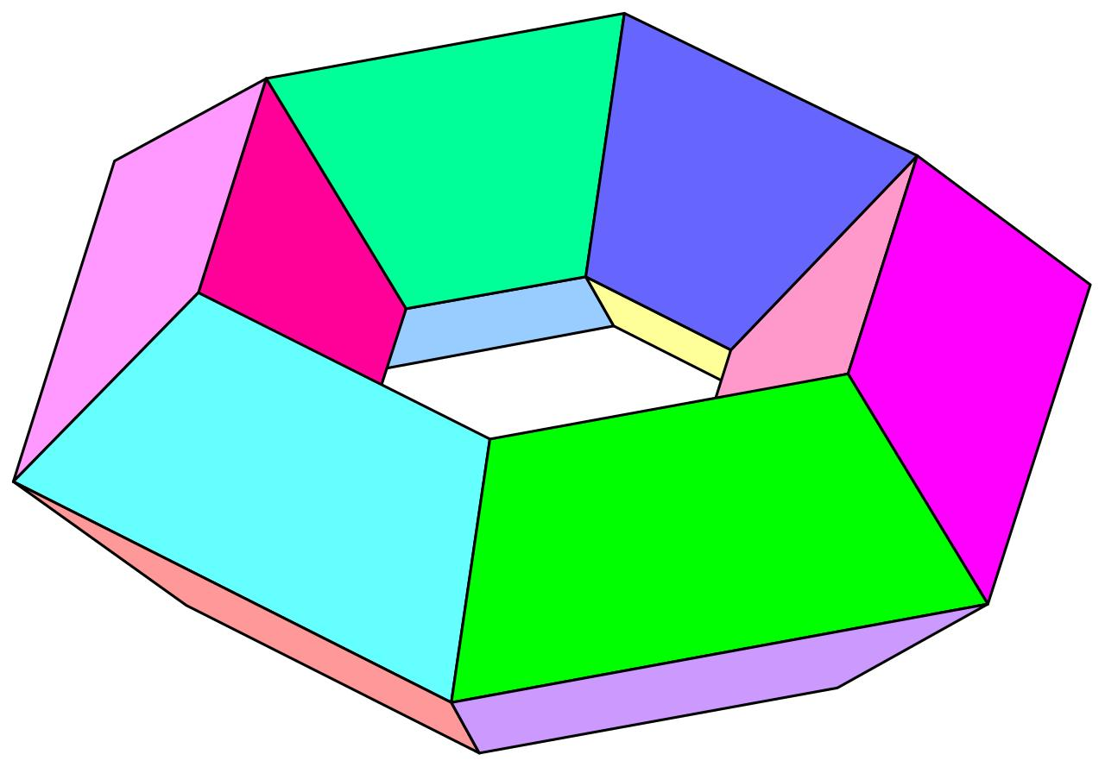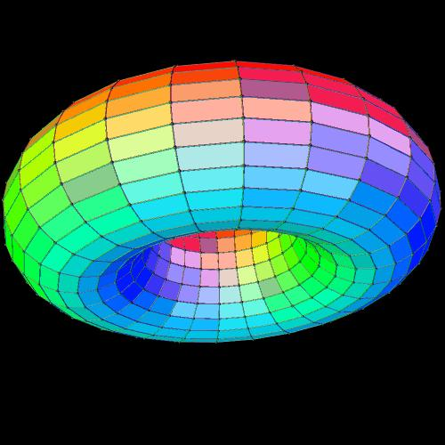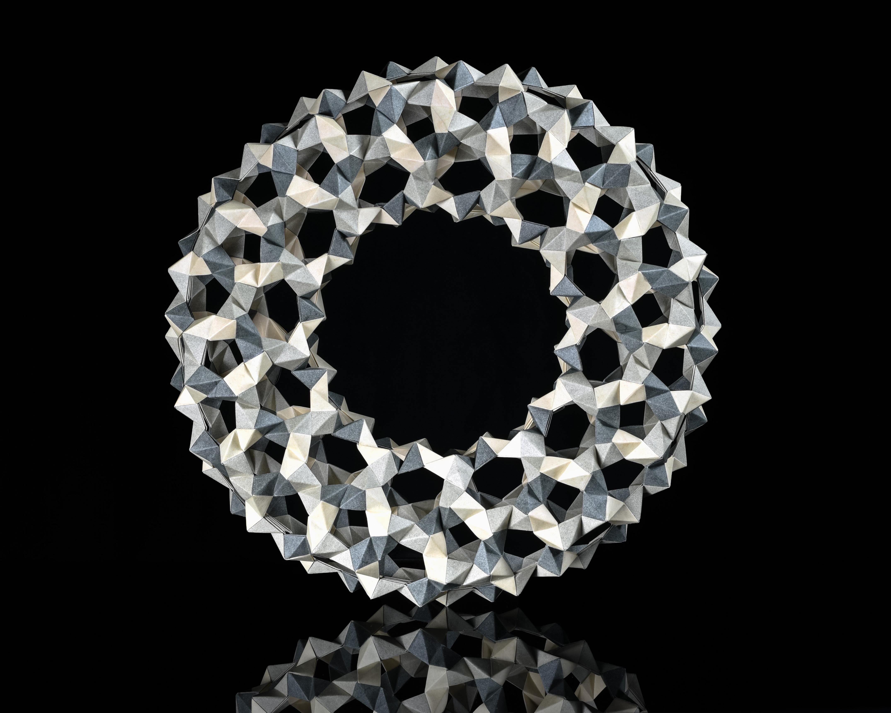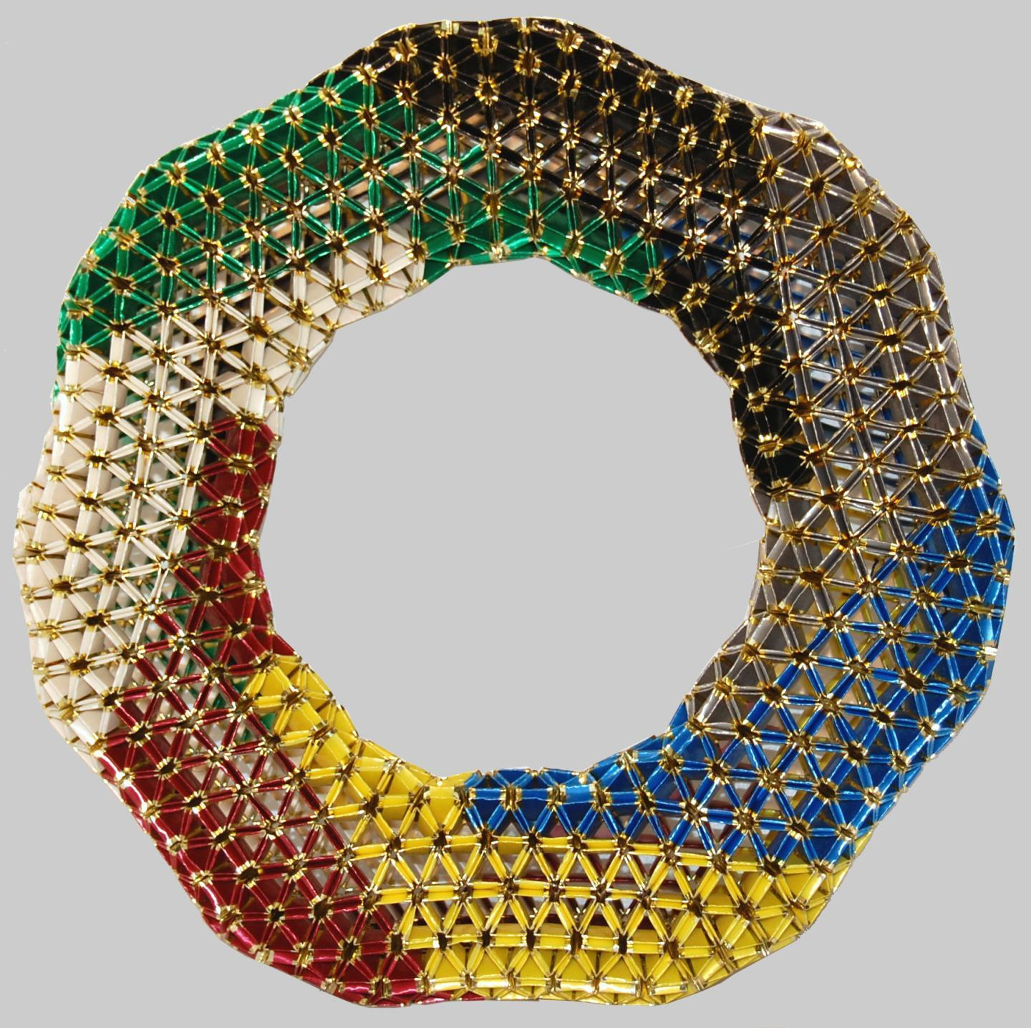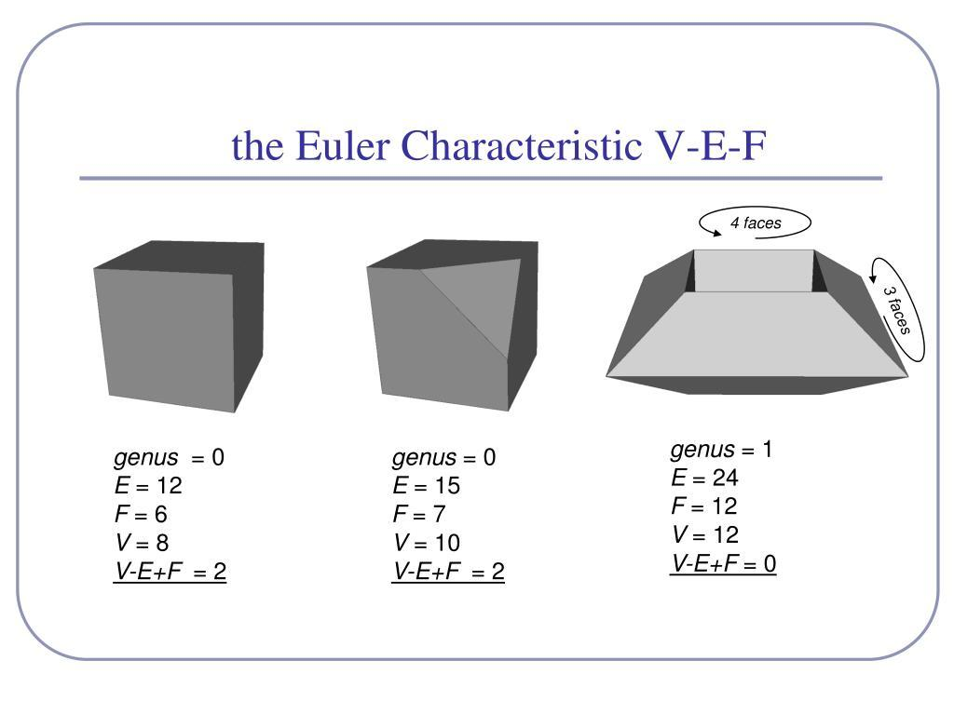
Characteristics:
- Contain openings or tunnels.
- May have a connected boundary with a nonzero genus.
- Their surfaces may have more complicated topology than ordinary indented polyhedra.
- Their face arrangements are generally not vertex-transitive in the non-uniform examples considered here.
Examples:
- Polyhedral torus.
- Polyhedral ring.
- Polyhedral structure with a through-hole.
Terminology note: A polyhedron with a cavity or through-hole is not necessarily the same as an ordinary concave polyhedron with a simple indentation. These structures can have different topological properties.

Non-Convex Irregular Composite Polyhedra
# Source: AI Source: Provided by: [Data Path: Persons Table -> ID Column: 1, Name_En Column: Motasem Essam] -> From: [ChatGPT] on [7/25/2026]
A Non-Convex Irregular Composite Polyhedron combines irregularly shaped polyhedral components to create a complex non-convex solid.
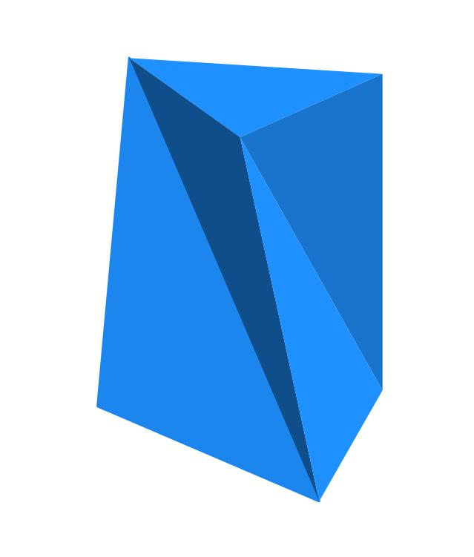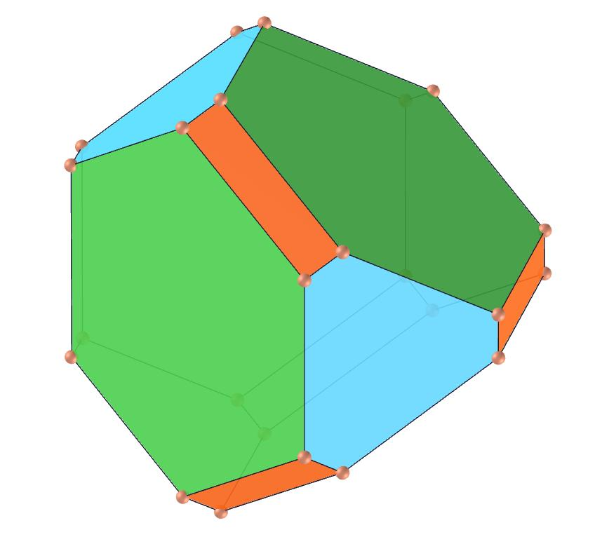
Characteristics:
- Contains multiple irregular components.
- May have unequal edge lengths and face dimensions.
- Has a non-uniform arrangement of vertices.
- May contain several inward regions.
- Can combine prisms, pyramids, and other polyhedral components.

Mathematical Characteristics
# Source: AI Source: Provided by: [Data Path: Persons Table -> ID Column: 1, Name_En Column: Motasem Essam] -> From: [ChatGPT] on [7/25/2026]
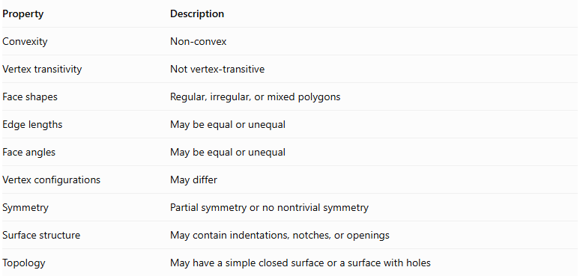
Property | Description
Convexity | Non-convex
Vertex transitivity | Not vertex-transitive
Face shapes | Regular, irregular, or mixed polygons
Edge lengths | May be equal or unequal
Face angles | May be equal or unequal
Vertex configurations | May differ
Symmetry | Partial symmetry or no nontrivial symmetry
Surface structure | May contain indentations, notches, or openings
Topology | May have a simple closed surface or a surface with holes

Convexity Test
# Source: AI Source: Provided by: [Data Path: Persons Table -> ID Column: 1, Name_En Column: Motasem Essam] -> From: [ChatGPT] on [7/25/2026]
A polyhedron is convex if every line segment joining any two points in the solid lies entirely inside or on its boundary.
For a non-convex polyhedron, there are points $A$ and $B$ such that:
$$overlineABnotsubseteqP$$
Where $P$ represents the polyhedral solid.

Euler's Formula
# Source: AI Source: Provided by: [Data Path: Persons Table -> ID Column: 1, Name_En Column: Motasem Essam] -> From: [ChatGPT] on [7/25/2026]
For a conventional connected polyhedron with a closed, non-self-intersecting boundary:
$$V-E+F=2-2g$$
Where:
- $V$ = Number of vertices.
- $E$ = Number of edges.
- $F$ = Number of faces.
- $g$ = Genus of the surface.
For a simple indented polyhedron with no through-holes, $g=0$, so:
$$V-E+F=2$$
For a polyhedral torus with one through-hole, $g=1$, so:
$$V-E+F=0$$

Special Example: Schönhardt Polyhedron
# Source: AI Source: Provided by: [Data Path: Persons Table -> ID Column: 1, Name_En Column: Motasem Essam] -> From: [ChatGPT] on [7/25/2026]
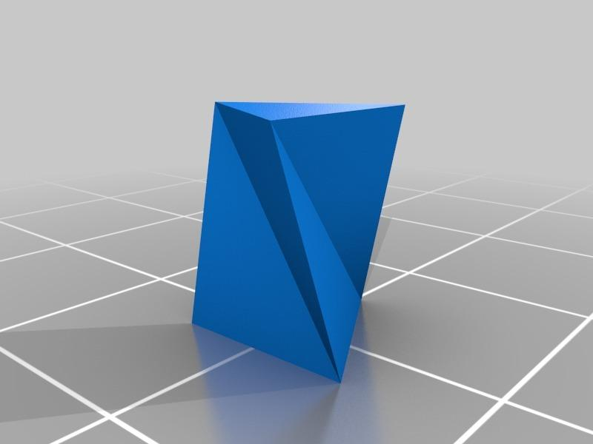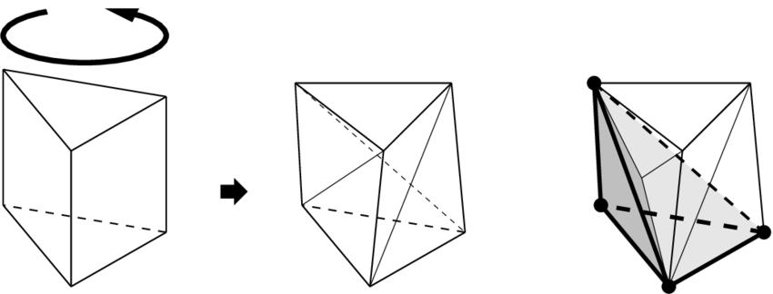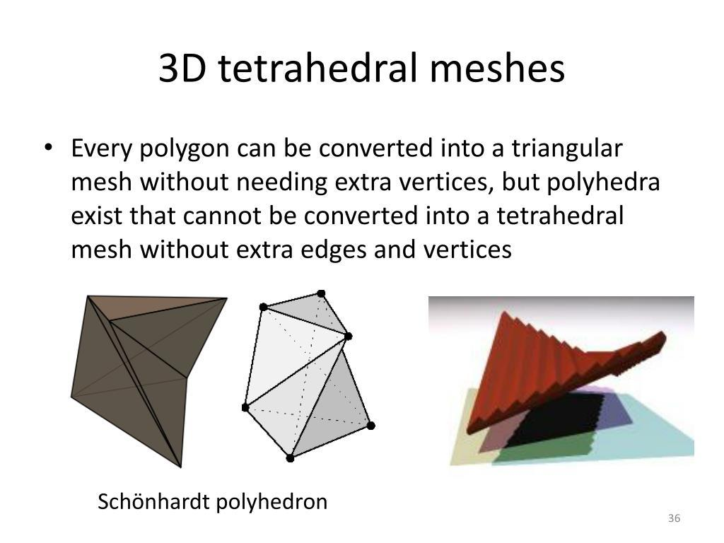
The Schönhardt Polyhedron is a well-known non-convex polyhedron constructed by twisting the upper triangular face of a triangular prism relative to its lower triangular face.
Its important properties include:
- Six vertices.
- Twelve edges.
- Eight triangular faces.
- A non-convex geometric structure.
- No internal diagonals between its nonadjacent vertices.
It is an example of a non-convex polyhedron that cannot be treated simply as an ordinary convex polyhedron with a notch.

Comparison: Convex vs. Non-Convex vs. Non-Uniform Non-Convex Polyhedra
# Source: AI Source: Provided by: [Data Path: Persons Table -> ID Column: 1, Name_En Column: Motasem Essam] -> From: [ChatGPT] on [7/25/2026]
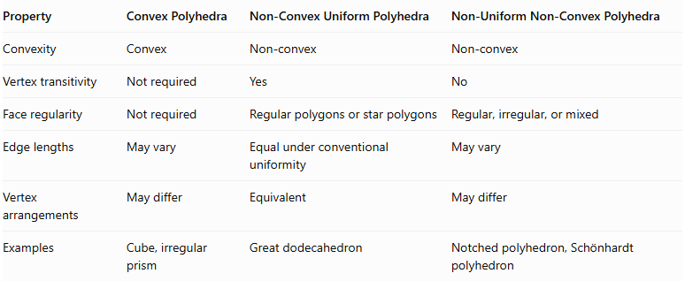
Property | Convex Polyhedra | Non-Convex Uniform Polyhedra | Non-Uniform Non-Convex Polyhedra
Convexity | Convex | Non-convex | Non-convex
Vertex transitivity | Not required | Yes | No
Face regularity | Not required | Regular polygons or star polygons | Regular, irregular, or mixed
Edge lengths | May vary | Equal under conventional uniformity | May vary
Vertex arrangements | May differ | Equivalent | May differ
Examples | Cube, irregular prism | Great dodecahedron | Notched polyhedron, Schönhardt polyhedron

Related Geometric Solids
# Source: AI Source: Provided by: [Data Path: Persons Table -> ID Column: 1, Name_En Column: Motasem Essam] -> From: [ChatGPT] on [7/25/2026]
- Concave Polyhedra – Polyhedra with non-convex geometry.
- Notched Polyhedra – Polyhedra with removed portions or inward notches.
- Composite Polyhedra – Polyhedra formed by combining multiple components.
- Polyhedral Tori – Polyhedral surfaces with a toroidal structure.
- Schönhardt Polyhedron – A special non-convex triangular-faced polyhedron.
- Non-Convex Uniform Polyhedra – Non-convex polyhedra that satisfy uniformity requirements.

Main Classification
# Source: AI Source: Provided by: [Data Path: Persons Table -> ID Column: 1, Name_En Column: Motasem Essam] -> From: [ChatGPT] on [7/25/2026]
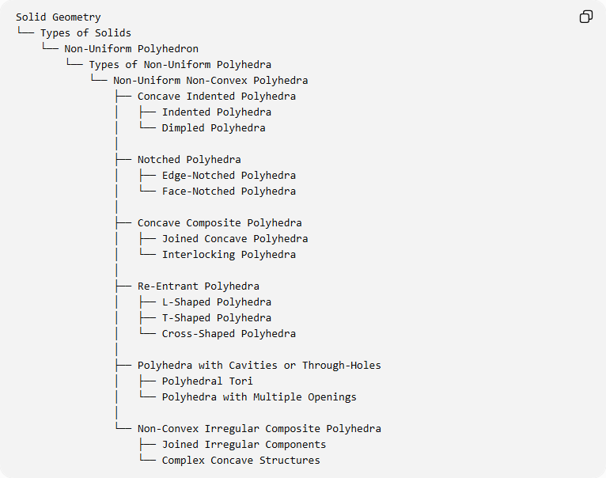
Solid Geometry
└── Types of Solids
└── Non-Uniform Polyhedron
└── Types of Non-Uniform Polyhedra
└── Non-Uniform Non-Convex Polyhedra
├── Concave Indented Polyhedra
│ ├── Indented Polyhedra
│ └── Dimpled Polyhedra
│
├── Notched Polyhedra
│ ├── Edge-Notched Polyhedra
│ └── Face-Notched Polyhedra
│
├── Concave Composite Polyhedra
│ ├── Joined Concave Polyhedra
│ └── Interlocking Polyhedra
│
├── Re-Entrant Polyhedra
│ ├── L-Shaped Polyhedra
│ ├── T-Shaped Polyhedra
│ └── Cross-Shaped Polyhedra
│
├── Polyhedra with Cavities or Through-Holes
│ ├── Polyhedral Tori
│ └── Polyhedra with Multiple Openings
│
└── Non-Convex Irregular Composite Polyhedra
├── Joined Irregular Components
└── Complex Concave Structures
Classification note: This is a proposed organizational taxonomy. Notched, indented, re-entrant, and composite describe geometric features or construction methods, so one polyhedron may belong to several of these groups. Through-hole structures are distinguished because they have different topological properties.

Key Points
# Source: AI Source: Provided by: [Data Path: Persons Table -> ID Column: 1, Name_En Column: Motasem Essam] -> From: [ChatGPT] on [7/25/2026]
- Non-uniform non-convex polyhedra are both non-convex and non-uniform.
- They may contain indentations, notches, inward corners, or openings.
- Their faces can be regular, irregular, or mixed.
- They may be created by cutting, joining, or modifying polyhedral components.
- Polyhedral tori have different topological properties from simple indented polyhedra.
- The Schönhardt polyhedron is an important example of a non-convex polyhedron.

Conclusion
# Source: AI Source: Provided by: [Data Path: Persons Table -> ID Column: 1, Name_En Column: Motasem Essam] -> From: [ChatGPT] on [7/25/2026]
Non-Uniform Non-Convex Polyhedra form a broad category of polyhedra characterized by inward geometric regions and non-equivalent vertex arrangements. Their structures include indented solids, notched solids, concave composites, re-entrant forms, and polyhedra with through-holes.

